STANDARD FORMAT OF “LEHENGA DESCRIPTION”


For Online Selling Products
Design Name: SITARA-B
Product Colours NO.: B3
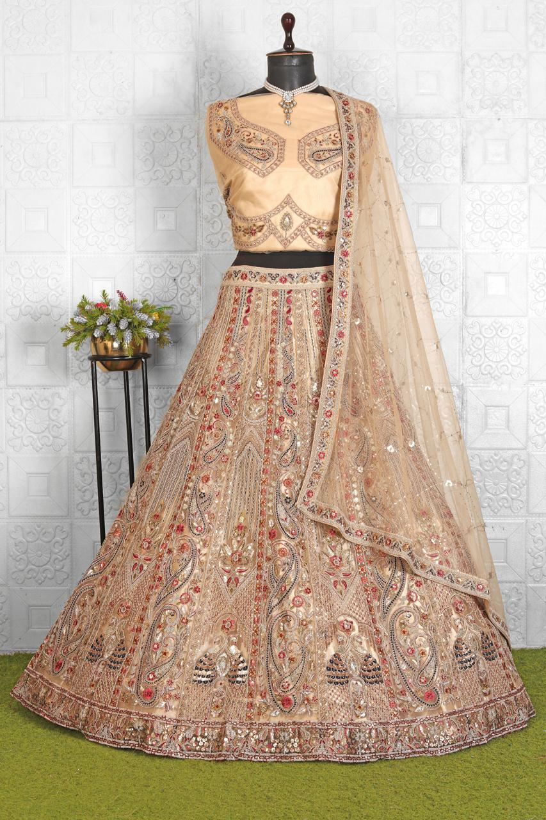
Particulars | Details
Lehenga Fabric | Net
Blouse Fabric | Net
Dupatta Fabric | Net
Work Type | Heavy Zari
Colour | Rabari
Pattern | Bridal Designer
Stitching Type | Semi-Stitched (Can be customized up to 44")
Occasion | Wedding, Reception, Engagement & Festive Wear
Fit Type | Regular Fit
Care Instructions | Dry Clean Only
Package Contents | 1 Lehenga, 1 Blouse Piece, 1 Dupatta

KEY HIGHLIGHTS
- Crafted from high-quality net fabric with a refined, luxurious finish
- Intricately designed with fine zari work for a rich ethnic appeal
- Includes a beautifully coordinated blouse and dupatta
- Ideal for weddings, receptions, and festive celebrations
- Semi-stitched for convenient customization and perfect fitting
- Comfortable, lightweight, and suitable for long-duration wear
- Blends timeless traditional style with modern sophistication

